**Tutor Classes Term 2**

**How do I sign my child up to a class?**

Your tutor will be in touch if they have available space. Children who have already been in the tutor’s class get first pick and then new students get any spare spaces.

Here is our list of classes for Term 2! If you wish to sign up your child, please fill out this google form: <https://forms.gle/hiBx4rZyods3uNTd8>

Classes will run from week 1 (week starting Monday 24th of April). Classes run until week 10 (week starting Monday 26th of June).

**Tuesday** Please note there will be no classes held on Tuesday 25th of April (ANZAC Day).

Art: Explore

Tutor: Janet Olmstead

$108 (9 weeks, includes materials)

2:50-3:50pm

Year 2-6

*Come along and learn to speak Chinese. Great for beginners and more fluent speakers.*

Chinese

Tutor: Janet Olmstead

$90 (9 weeks)

3:55-4:40pm

*Come and explore art!*

**Wednesday**

Guitar: Beginners - please bring a guitar

Tutor: Nathan Bird

3:15-3:45pm

$90 (10 weeks)

Singing: Explore

Tutor: Ashley Bird

2:45-3:30pm

$90 (10 weeks)

**Thursday**

Drama

Tutor: Ashley Bird

2:45-3:30pm

$90 (10 weeks)

Ukulele: Beginners - please bring a ukulele

Tutor: Nathan Bird

2:45-3:15pm

$90 (10 weeks)

Please note that classes will only go ahead if we have enough interest.

**ALL CLASSES START WEEK THREE OF TERM 1. PAYMENT FOR CLASSES ARE DUE TO INDIVIDUAL TUTORS BEFORE 24th APRIL 2023.**

Tutors will send bank account details to parents once your child is confirmed in their class.

**DESCRIPTION OF CLASSES**

**Art: Explore**

**Tutor: Janet Olmstead**

*Janet has been a long time tutor at Star of the Sea and excited to offer this art class for our students!*

**Chinese: Beginners**

**Tutor: Janet Olmstead**

*Janet has been a long time tutor at Star of the Sea and excited to offer this Chinese class again for our students!*

**Singing Lessons**

**Tutor: Ashley Bird**

*In this class, I aim to give students the opportunity to explore the world of singing. Together we will learn singing techniques, how to best take care of our voices, and develop our stage presence, all while we sing some fun songs. I can't wait to help your children find their inner superstar!*

**Ukulele Lessons**

**Tutor: Nathan Bird**

**Each child must have their own instrument.**

**Guitar Lessons**

**Tutor: Nathan Bird**

**Each child must have their own instrument.**

*Sign up for ukulele and guitar lessons with Nathan! A fun and great opportunity to learn these musical instruments!*

**Drama Class**

**Tutor: Ashley Bird**

*Students will learn the foundational skills for acting and performing: Voice, movement, narrative, character and confidence. All activities will be group based, game-oriented and fun, meaning that even the shyest of actors will have a safe place to communicate, grow and improve in their drama and social skills. In later sessions we will explore different performance genres and stories, such a mime, musical theatre, comedy and fables. Each session will include a warm-up game, a learning time and a short student-directed skits.*

**TUTOR PROFILES**

**Ashley Bird**

**Singing & Drama**

**Administrator of Tutor Groups**

Ashley is a mum to one toddler has been singing for most of her life, coming from a very musical family and has been singing in her local church music team for 15 years. Ashley and her husband Nathan have pursued music together in various ways, including performing in their church production, and having the privilege of singing many brides down the aisle! Ashley is so excited to share the joy of singing with her students. This Term Ashley will also be teaching the drama class, helping students explore their voice, gain confidence, and learn more about the stage.

**Nathan Bird**

**Ukulele and Guitar Tutor**

Nathan Bird has been playing guitar for 15 years, and teaching guitar for 11 years, including 5 years at Our Lady Star of the Sea from 2010-2014. He has obtained a bachelor of music in Jazz Performance from Auckland University, and has been singing and playing in church for over a decade. He also picked up ukulele and really enjoys playing. He has a passion for music, and a desire to see his students really grow in their gifts.

**Janet Olmstead**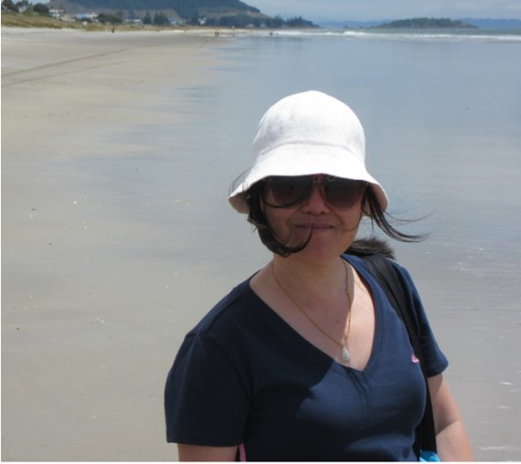

**Chinese and Art Tutor**

Chinese language teaching degree – Foshan University, China。She studied Fine arts at Auckland University - Elam Art School in 2007. Janet has been teaching in Chinese and art for 9 years in China and runs Chinese and art classes in Botany for the past 12 years.

**What are tutor classes?**

They are classes that are run after school that provide an affordable and fun way for your child to explore areas they may be passionate about. Classes range from 30 minutes to 1 hour and range from musical, art and language.

**Who are the tutors?**

All tutor profiles are listed below. Each tutor has a particular passion and skill in the field that they teach. All our tutors are police checked through the school.

**I would like to become a tutor, who do I talk to?**

Do you have the ability to teach a musical instrument, or dance or even a class that you have in mind that could be beneficial to our tutor program? Contact Ashley at bird.tutorclasses@gmail.com