

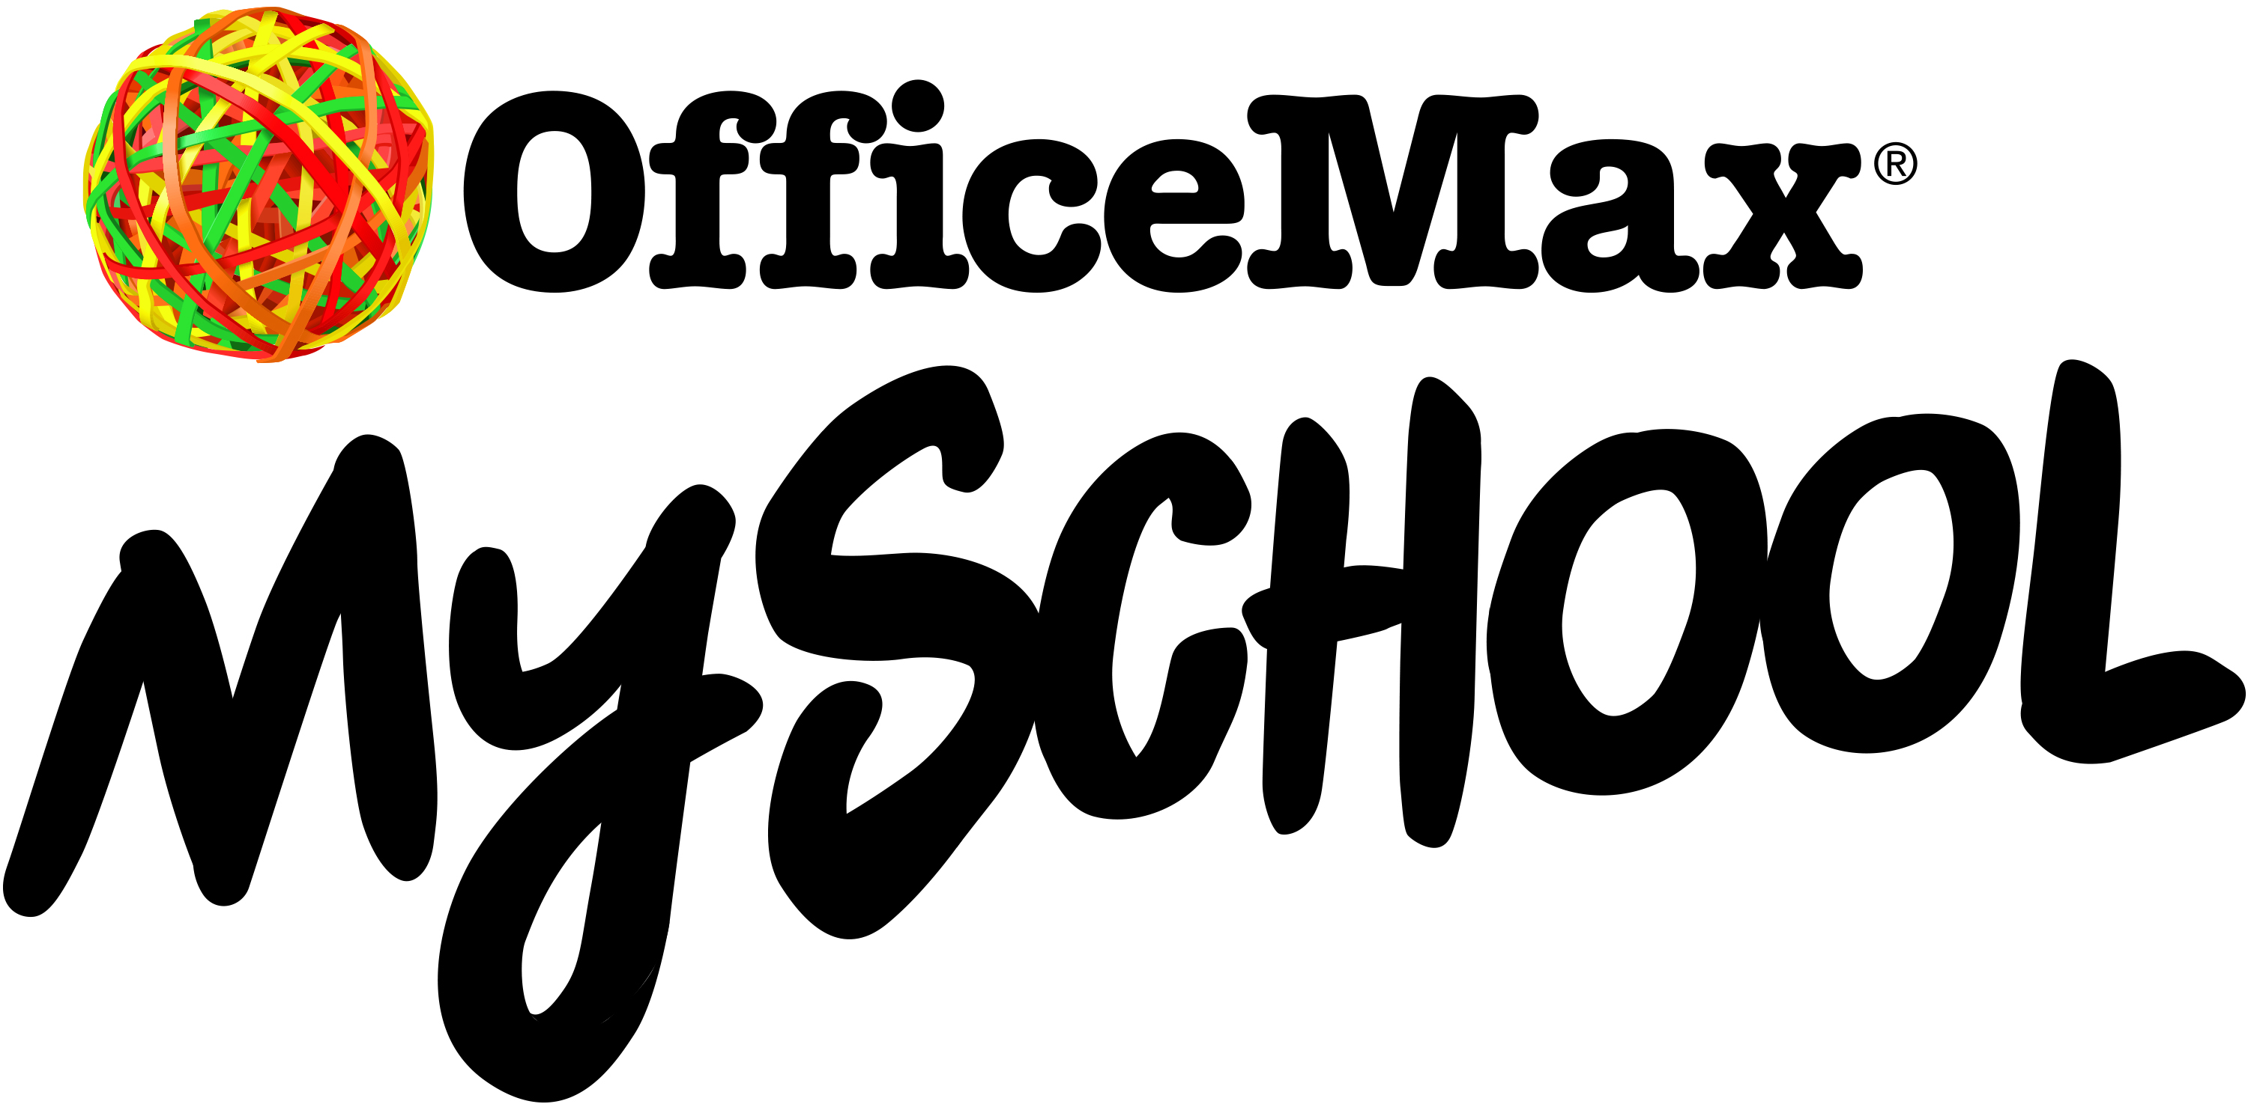

December 2020

Dear Parent / Guardian,

**Re: Stationery will be online to order soon!**

We’ve teamed up with OfficeMax to make getting school ready faster! Our back to school stationery lists will be published on **18 December 2020** on the [OfficeMax MySchool website](https://www.myschool.co.nz/).

This year OfficeMax have introduced Laybuy*, so you can pay in 6 weekly, interest-free instalments - and still get your order right away.

We encourage you to order early to ensure your child has all their stationery requirements ready to go for the start of Term 1 2021. Don’t wait until mid-January when the ‘team of 5 million’ get home from holiday - order now and avoid the back to school rush.

It’s easy to shop online at [myschool.co.nz](https://www.myschool.co.nz/). Just search for our school, select your child's class and follow the instructions on the easy-to-use website.

If you prefer you can call the OfficeMax MySchool team on 0800 724 440 Monday to Friday, 8.30am - 5pm.

**OfficeMax makes it easy to get back to school ready with these great benefits**

* **Free delivery** on orders over $46*
* **Pay now or in easy instalments** - internet banking, credit cards, debit cards or pay in 6 weekly, interest-free instalments with Laybuy*
* **School Rewards** - when you shop on myschool.co.nz we earn rewards* that can be used to purchase extra resources for school
* **Price match promise** - shop with confidence, if you find a lower price OfficeMax will match it*
* **Save valuable holiday time** - avoid queues and busy shopping malls by shopping online from the safety and comfort of your home

Please don’t hesitate to contact the school if you have any queries about OfficeMax MySchool. We look forward to your child having a successful start to the new school year!

Kind regards

***Louise Campbell***

***Principal***

***OUR LADY STAR OF THE SEA SCHOOL***