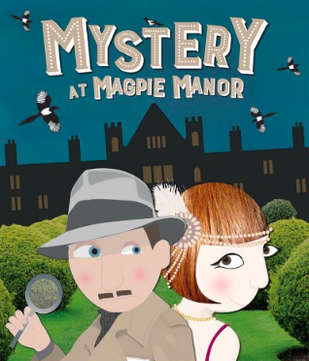

Our Lady Star of the Sea
Middle Team Newsletter Term 3 2019
A big welcome to our new families that are joining our team this term. We hope your time with us will be rewarding and you enjoy being part of the ‘Star family’.

Middle Team Production
This term is going to be a busy term with our up and coming ‘Mystery at Magpie Manor’ production. Rehearsals are underway and we can’t wait to share our wonderful talents with you in Week 10. Over the next few weeks, your child may be asked to bring along some items of clothing for them to wear as part of their costume. We are in specific need of boys suits, black/brown/Navy pants and white shirts. If you are able to help us with this, can you please let your classroom teacher know. These will be well looked after and returned to you after the show.
Production Dates
- Tuesday 24th September 6:30pm
- Wednesday 25th September 11:30am
- Thursday 26th September 6:30pm
Tickets to go on sale Monday 2nd September at the school office.

Reminders

- PE gear to be at school EVERY DAY.
- Readers and RE books to be returned daily.
- No new reading books will be given out unless the old books are returned.
- Children will be unable to bring a reading book or library book home unless they have a book bag.
Concept learning
This year our overarching concept is Joyfulness and we want the students to “Lead like Jesus to bring joyfulness to others”.
Our term three concept is Action with the understanding that we need to Take action to help bring joy to the world we live in. Each class will have their own focus for this learning and will be connected across the curriculum. We will be exploring the questions:
- What is Catholic Faith in action?
- Why take action?
- What actions can I do to make a lasting impact?

Middle Team Trip
During term 2, the children learnt about deforestation and how it has created disharmony on our plant. As part of our ‘Action’ learning for this term, the Middle team will be taking action against deforestation and giving back to our community. On Friday 23rd August, we will be travelling to Pigeon Mountain where we will be planting trees in the wetlands. A notice will be coming home soon with more details.

Some important dates for your diary…
31 July – School Cross Country
7 & 8 August – Dance festival at Somerville Intermediate
13 August – Interschool Cross Country
15 August – Feast Day – Star of the Sea Idol Finals
19 August – Class Photos
21 August – Gymnastics Competition
30 August – Father’s Day Liturgy
6 September – Team Photos
12 September – Champion of Champion Gym Comp
20 September – Maher House Assembly
23 September – Production Week
Team Assemblies Friday’s at 8:45am in Weeks 2, 4, 8

